GPS Geolocation values internet third party site and google

Nothing much:

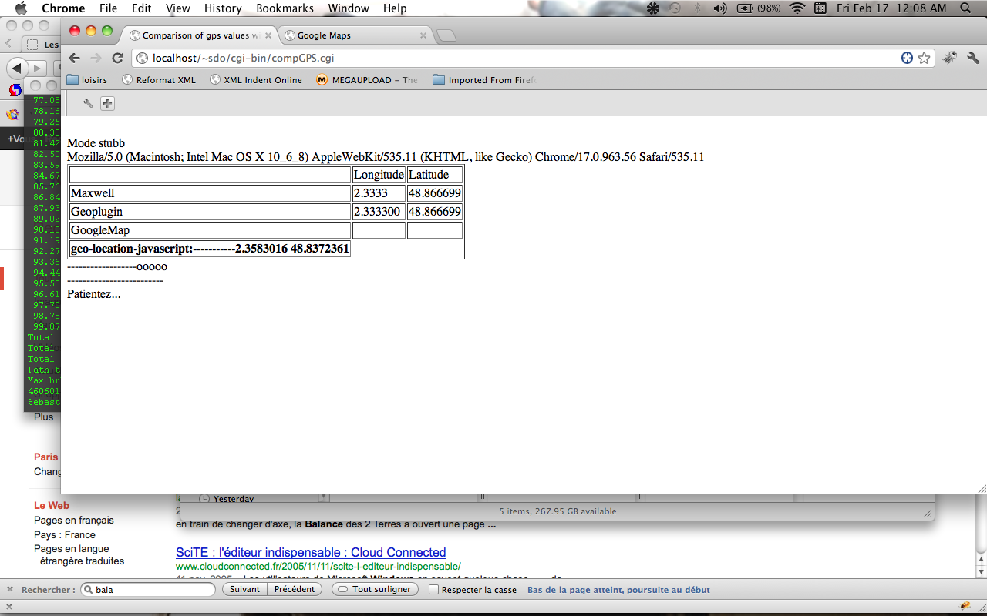
Data can be collected but now cannot format it as desired. Occurs with innerHTML field.

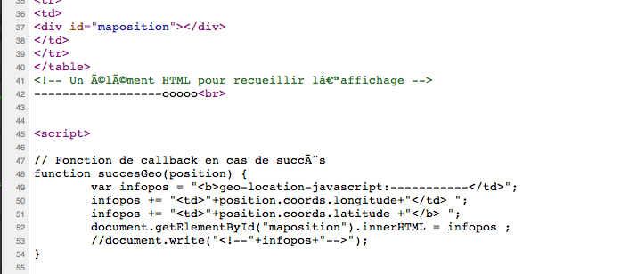
At the first glance: it seems that tags for the table open, close don't work within innerHTML field in javascript.

Another solution that does not work is to define div field with different names id. Then with the getElementById and innerHTML assign a value. This should have printed the values. But it does not work too.

The only solution is to write one string and concatenates values and then assign it to innerHTML fiel at a specific div id field.

Now we have the values but we need to store them. To do that we will use ajax. That's another subject because we have to align values at server side.

First try to make things nice. Compared all stuff on a map,... Then make decision regarded values.

CompGPS.cgi
<script language="JavaScript" src="http://www.geoplugin.net/javascript.gp" type="text/javascript"></script>
<script type="text/javascript" src="http://www.google.com/jsapi?key=ABQIAAAAO3m8Ej0Lg8Y0CEbotFaCRhQf4HhQWU1BJ6HFjMXkLlupKjyNORTWeHCgnHqZz-Zn96kXXmCsK_O1Bw"></script>

<!-- Google Gears -->
<script src="http://code.google.com/apis/gears/gears_init.js"></script>

<!-- Geo-location-javascript : http://code.google.com/p/geo-location-javascript/ -->
<script src="../geo-location-javascript/js/geo.js"></script>

<script type="text/javascript">
if(google.loader.ClientLocation) {
visitor_lat = google.loader.ClientLocation.latitude;
visitor_lon = google.loader.ClientLocation.longitude;
} else {
visitor_lat = "NDef";
visitor_lon = "NDef";
}
# document.write(visitor_lon+ ","+visitor_lat);
</script>

<br>
Mode stubb<br><html>
<head>
<title>Comparison of gps values with third party services</title>
<script language="JavaScript" src="http://www.geoplugin.net/javascript.gp" type="text/javascript"></script>
<script type="text/javascript" src="http://www.google.com/jsapi?key=ABQIAAAAO3m8Ej0Lg8Y0CEbotFaCRhQf4HhQWU1BJ6HFjMXkLlupKjyNORTWeHCgnHqZz-Zn96kXXmCsK_O1Bw"></script>
</head>
<body>
Mozilla/5.0 (Macintosh; Intel Mac OS X 10_6_8) AppleWebKit/534.52.7 (KHTML, like Gecko) Version/5.1.2 Safari/534.52.7<br>
<table border=1>
<tr><td></td> <td>Longitude</td> <td>Latitude</td></tr>
<tr><td>Maxwell</td> <td>2.3333</td> <td>48.866699</td> </tr>
<tr><td>Geoplugin</td> <td><script>document.write(geoplugin_longitude());</script></td> <td><script>document.write(geoplugin_latitude());</script></td> </tr>
<tr><td>GoogleMap</td> <td><script>document.write(visitor_lon);</script></td> <td><script>document.write(visitor_lat);</script></td> </tr>
<tr>
<td>
<div id="maposition"></div>
</td>
</tr>
</table>
<!-- Un Ã©lÃ©ment HTML pour recueillir lâ€™affichage -->
------------------ooooo<br>

<script>

// Fonction de callback en cas de succÃ¨s
function succesGeo(position) {
var infopos = "<b>geo-location-javascript:-----------</td>";
infopos += "<td>"+position.coords.longitude+"</td> ";
infopos += "<td>"+position.coords.latitude +"</b> ";
document.getElementById("maposition").innerHTML = infopos ;
//document.write("<!--"+infopos+"-->");
}

// Fonction de callback en cas dâ€™erreur
function erreurGeo(error) {
var info = "<td>geo-location-javascript</td>";
///var info = "Erreur lors de la gÃ©olocalisation : ";
info += "<td>" + error.message + "</td>" ;
document.getElementById("maposition").innerHTML = "<tr>" + info + "</tr>" ;
}

// Initialisation du framework et gÃ©olocalisation
if(geo_position_js.init()){
document.getElementById("maposition").innerHTML = "En cours...";
geo_position_js.getCurrentPosition(succesGeo,erreurGeo);
} else {
alert("Ce navigateur ne supporte pas la gÃ©olocalisation");
}

</script>
-------------------------<br>
<script type="text/javascript">

function initialize() {

var adr = "ta latitude : " + google.loader.ClientLocation.latitude +"<br>";

adr += "ta longitude : " + google.loader.ClientLocation.longitude +"<br>";

adr += "ta ville : " + google.loader.ClientLocation.address.city +"<br>";

adr += "ta region : " + google.loader.ClientLocation.address.region +"<br>";

adr += "ton pays : " + google.loader.ClientLocation.address.country +"<br>";

document.getElementById("test_gloader").innerHTML = adr;

}

</script>

</head>

<body onload="initialize()">
<div id="test_gloader">Patientez...</div>
<script language="JavaScript" src="http://www.geoplugin.net/javascript.gp" type="text/javascript"></script>
</body>
</html>

